Word 365 Tips

Rylander Consulting
www.RylanderConsulting.com
sandy@rylanderconsulting.com
425.445.0064

Table of Contents

Screen Display Tips 1
Create a Shortcut to a Recently Opened Document by Pinning 4
Push-pins 4
Open as Copy 4
Open and Repair 4
Increase the Number of Documents Displayed on the Recent List 4
Tell Me What You Want to Do 5
The Quick Access Toolbar 6
Add/Remove Tools From the Ribbon 6
Add Tools not on the Ribbon and Move QAT Tools using Customize 6
Move Tools on the QAT. 8
Add a separator by double clicking Separator at the top of any of the command lists. 8
Great tools to have on your Quick Access Toolbar. 9
Paste Preview 10
Editing a Document 11
Navigating in a Document 11
Selecting Text 11
Document Navigation Pane 12
Move and Copy 13
Using Drag and Drop 13
Using the Clipboard Pane 13
Formatting Text 15
Copy Formatting Using the Format Painter 15
Screen Capture Tool 16
Inserting an Entire Screenshot of any Open Window 16
Take a Screen Clip 16
Building Blocks/Quick Parts 17
Quick Parts Gallery 17
Create an AutoText Quick Part 17
Insert an AutoText Quick Part 19
Headers/Footers Gallery 19
Delete a Building Block 20
Building Blocks Organizer 21
Add/Edit/Remove Presets 23
Find, Advanced Find and Replace 26
Find – Navigation Pane Search 26
Advanced Find 26
Find Each Occurrence Individually 26
Select All Instances of Found Text 26
Highlight All Instances of Found Text 27
Replace 28
Appendix A –Word Shortcuts 30

Screen Display Tips
- Scroll through tabs on the Ribbon – Pointing to a tab on the ribbon and move the wheel.
- View Zoom – Hold your control key down as you move your mouse wheel to scroll in/out.
- Maximize/Restore – Double click the title bar.
- Dialog Box Launchers – Access dialog boxes using the arrows in the bottom right corner of groups.
Help
Ribbon
File Menu
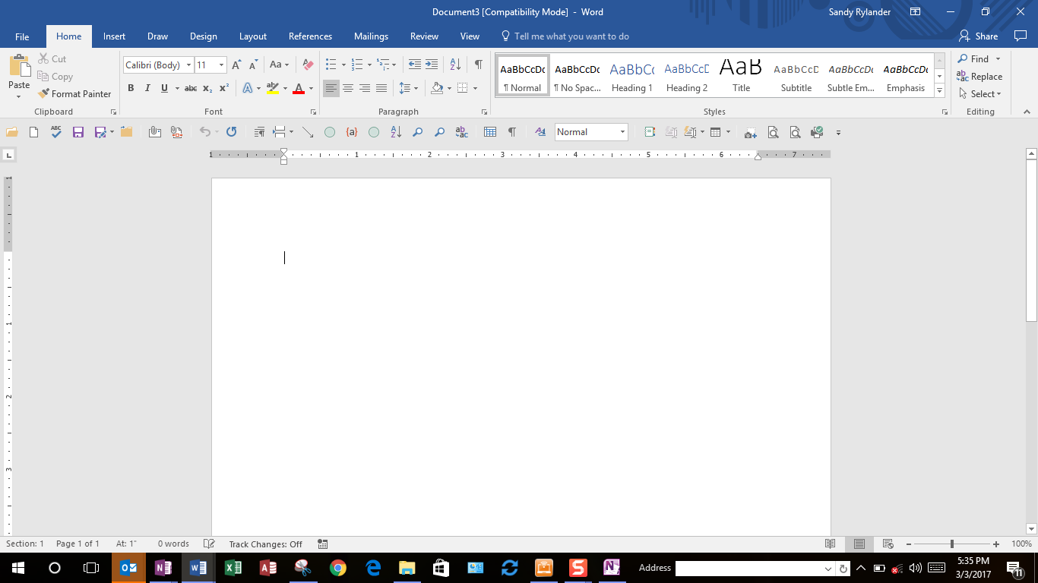
Spell Check
Show/Hide Navigation Pane
Show/Hide GoTo Dialog Box
Display the Navigation Pane
Dialog Box Launcher
Quick Access Toolbar
View Tools
View Zoom Slider

- Display the Navigation Pane: Click the Page Number on the status bar.

- Add useful tools to the Status Bar – Right Click on the Status Bar to add handy tools like Track Changes, Sections, Vertical Page Position etc. Click the desired tool to check (select) them or uncheck (deselect).
` 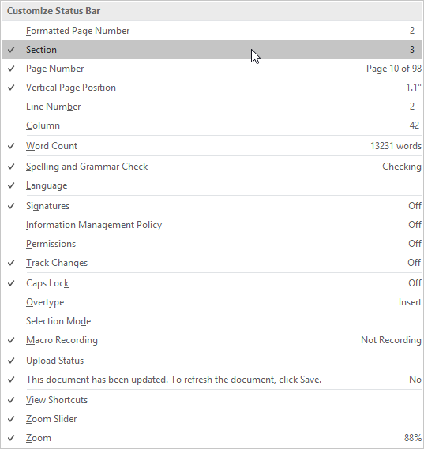
- Go to a Page/Find/Replace – Click Section Number or the Vertical Position in the bottom left corner of the status bar or press Ctrl + G.
Allows you to go directly to a particular Page, Section, Footnote etc.. See dialog box below.
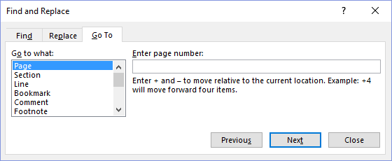
- Quickly Find Objects - Use the Find tools in the Find box on the Navigation Pane to find Graphics, Tables, Equations, Footnotes/Endnotes and Comments.
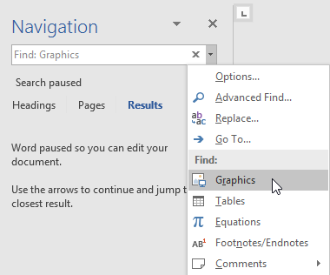

- Click the drop-down arrow on the Find box in the Navigation Pane.
- Select the type of object you wish to find.
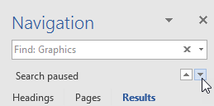
- Use the arrow keys to navigate forward and backward.

Create a Shortcut to a Recently Opened Document by Pinning
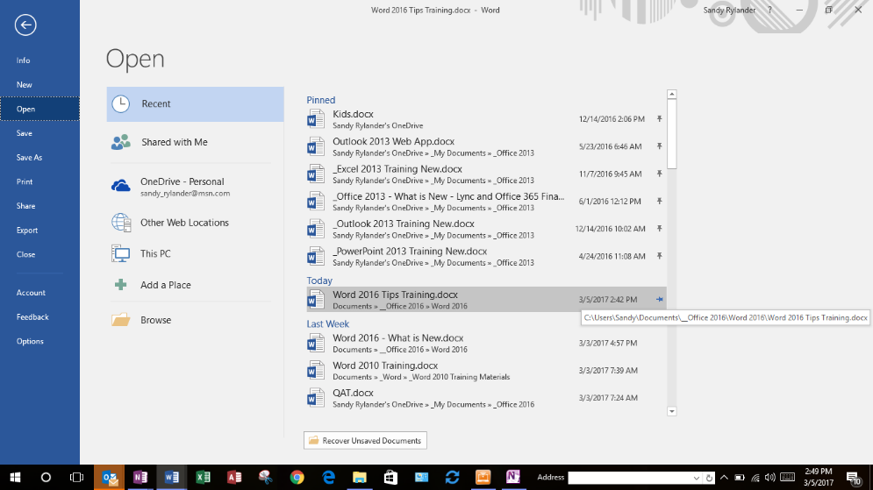
You can create a shortcut for a recently opened document hovering over the document on the File, Open Recent Documents list. This shortcut will remain at the top of the Recent list until you click it again to
remove the pin.
Push Pin Documents

Push-pins
The Recent Documents and Recent Places lists have an added feature of push-pins off to the right of the document and folder names. Click a push-pin to pin the file and keep the document or folder from scrolling off the list. Click the push-pin again to unpin it.

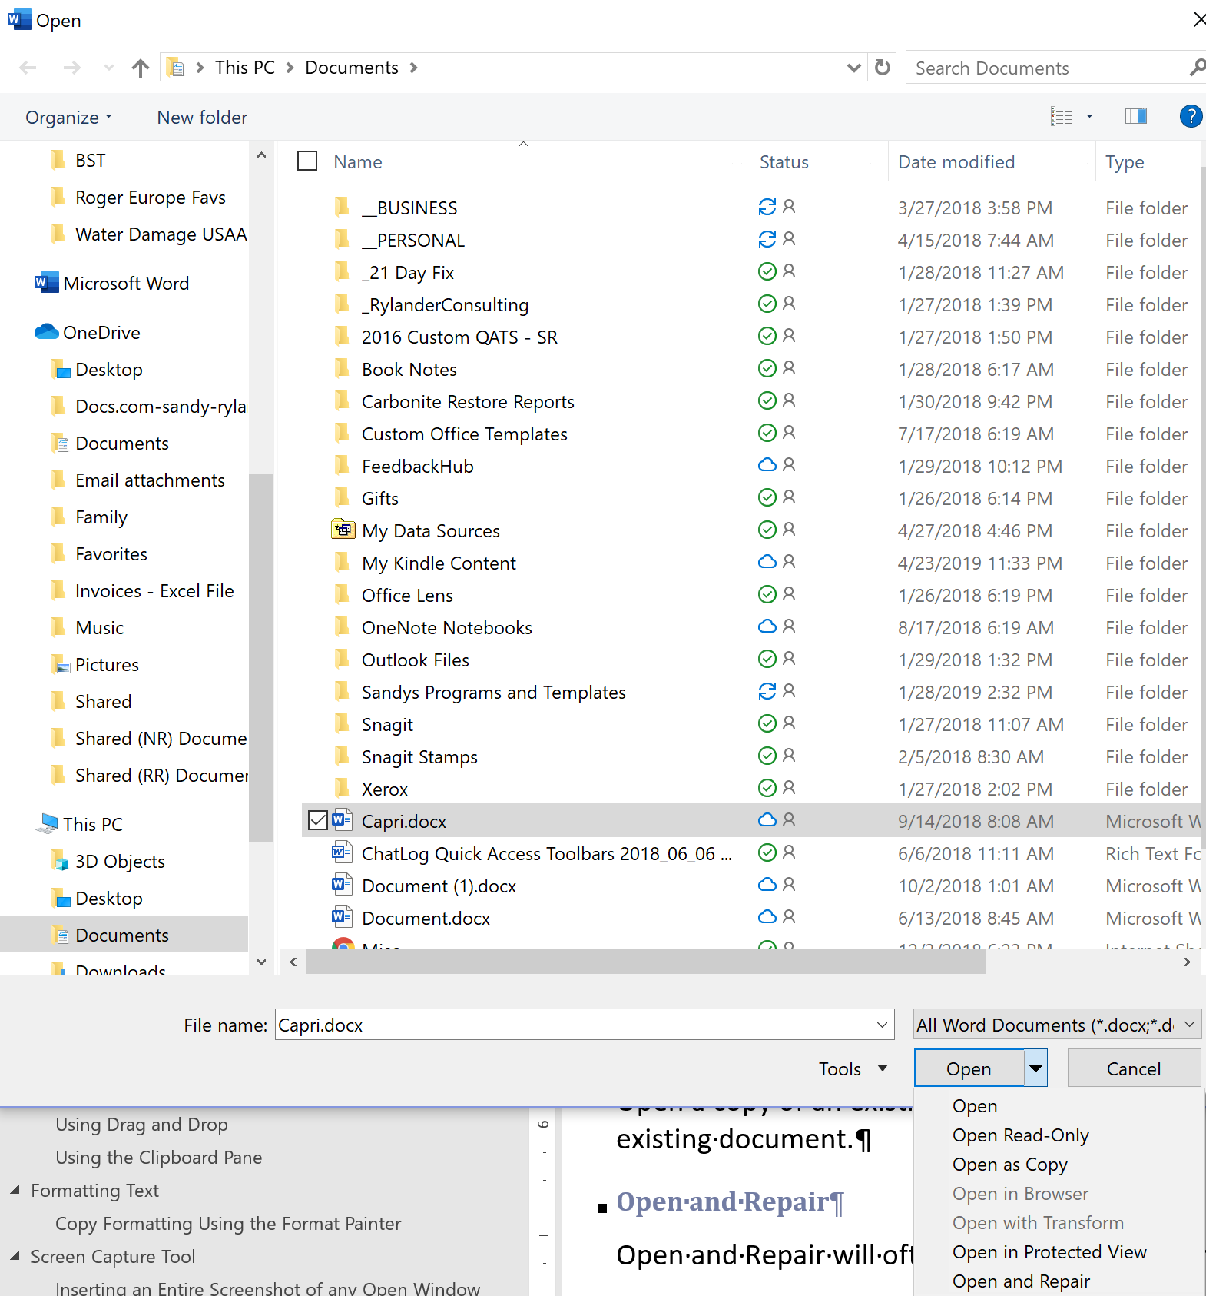
Open Options

Open as Copy
Open a copy of an existing document to prevent you from accidentally saving a document on top of an existing document.

Open and Repair
Open and Repair will often repair documents that have corruption.

Increase the Number of Documents Displayed on the Recent List
By default this list shows 25 documents, but you can display up to 50 documents on this list.
- Select File, Options, Advanced, Display, Show this Number of Recent Documents to change the number of documents displayed.
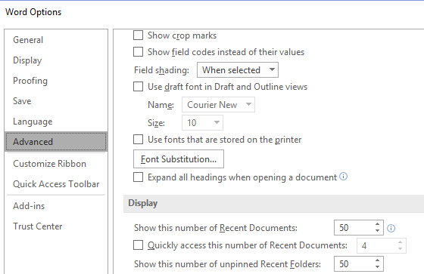
Increase the number of Documents displayed.
Increase the number of Folders displayed.

Tell Me (What You Want to Do)
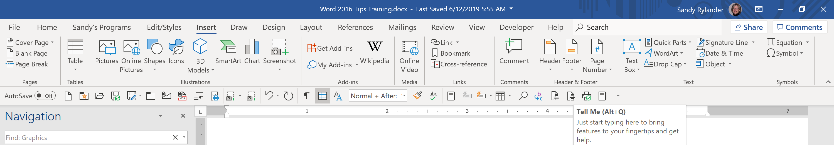
The Search icon in the Ribbon displays “Tell me” when you hover over it.
When you type something in the Tell Me field, you’ll search through Outlook’s list of commands which are then also useable from list of results.
So, if you don’t know how to insert a Footnote, simply type “Foot” in the Tell Me field and you can click on the command from the results.
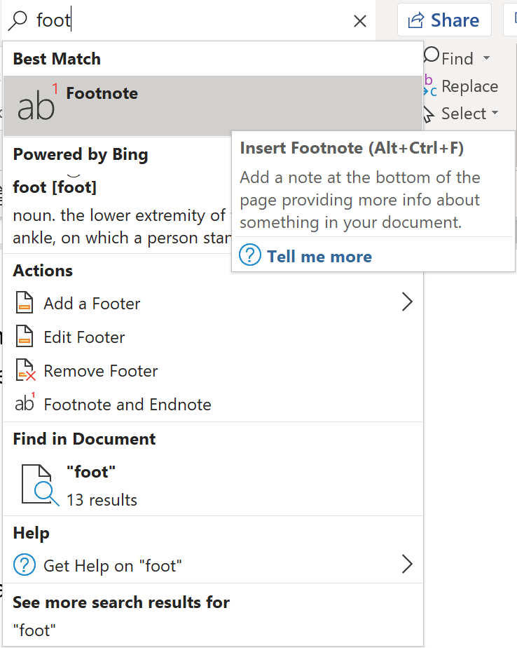
Clicking on the “Get Help” link will open the regular Help viewer and the “Smart Lookup” link will open an “Insights” pane in Outlook and performs a web search with Bing. If you use either of these, make sure you type the complete word “Footnote”.

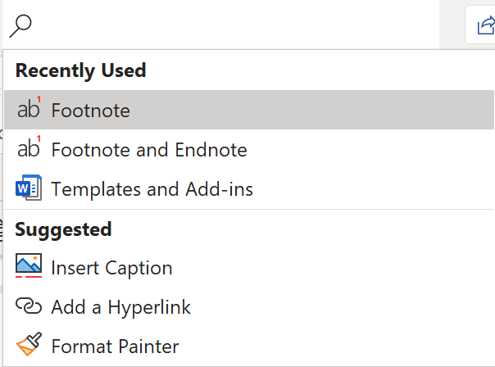
When you click in the Search (Tell Me) box, you will see a list of the last five commands you ran from within Search. This will save you time getting to the feature you need.

The Quick Access Toolbar
The Quick Access toolbar is always visible and therefore an excellent toolbar for your most used commands. While the Ribbon changes according to the selected Tab, the Quick Access toolbar stays the same.

Add/Remove Tools From the Ribbon
The Quick Access toolbar can be customized very easily. Simply right click on any tool and select Add to Quick Access Toolbar. You can also right click on any tool and select Customize Quick Access toolbar to see all customization options.

- Add the Sort tool to the Quick Access toolbar (QAT).
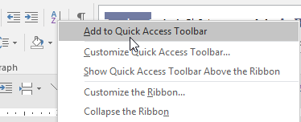
Right click on desired tool to add to quick access toolbar.
Sort Tool
- Select the Home tab.
- Right click the Sort tool.
- Select Add to Quick Access Toolbar.
The tool is added to the end of the toolbar.
- Remove the Sort Tool from the Quick Access Toolbar.
- Right click the Sort tool on the Quick Access toolbar and select Remove from Quick Access Toolbar.

Add Tools not on the Ribbon and Move QAT Tools using Customize
- Right click the Quick Access toolbar and select Customize Quick Access Toolbar.
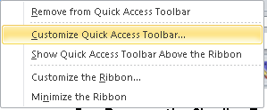
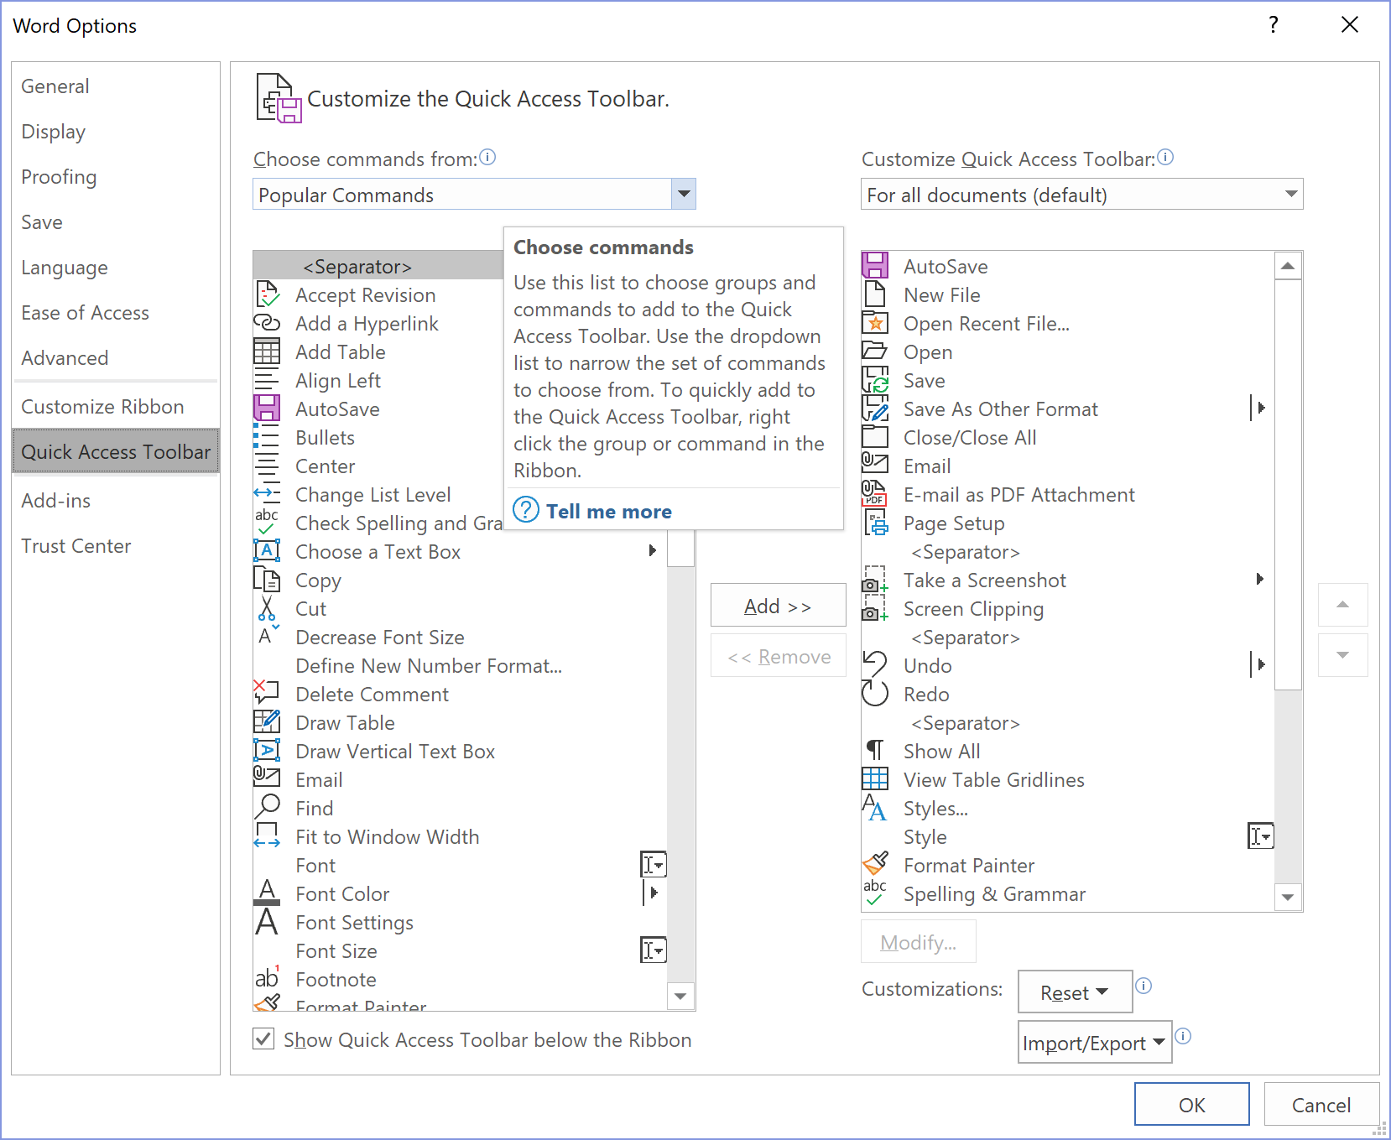
- The following dialog box appears. The commands on the left are the ones that can be added to the toolbar and the commands on the right are the ones that are already on the toolbar.
Change from Popular Commands to Office Menu to add the Print tool.

- To add a tool, double click the tool in the left column or click on it once and then click Add. To remove a tool, double click the tool in the right column or click on it once and then click Remove.
- To select from all commands in Word, click the down-arrow next to Popular Commands and select All Commands. You will find commands here that you won’t find anywhere else in Word!
Tip Some of my favorite are: Calculator (which appears as Formula once added to the QAT), Select Text with similar formatting
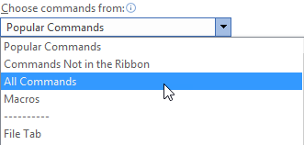

Move Tools on the QAT.
- Select the Command desired and click the Up or Down arrows to move them into the correct order.
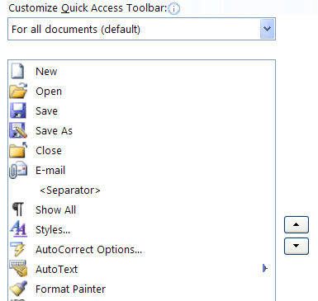

Add a separator by double clicking Separator at the top of any of the command lists.
Tip To add a command below another command already on the Quick Access toolbar, click on the tool below which you want the new tool to appear and then double click on the tool you wish to add. For example, to add Print Preview after Spell Check, click on Spell Check on the right side and then double click Print Preview on the left side.

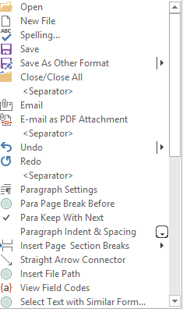
Great tools to have on your Quick Access Toolbar.
- Open
- New File
- Spelling
- Save
- Save As Other Format
- Close/Close All
- Separator
- Email
- Email as PDF Attachment
- Separator
- Undo
- Redo
- Separator
- Paragraph Settings
- Para Page Break Before
- Para Keep with Next
- Paragraph Indent & Spacing
- Insert Page Section Breaks
- Straight Arrow Connector
- Insert File Path
- View Field Codes
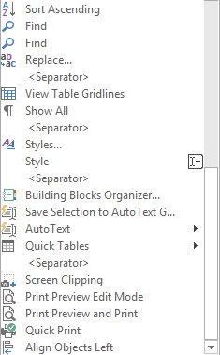
- Select Text with Similar Formatting
- Sort Ascending
- Find
- Find (Advanced)
- Replace
- Separator
- View Table Gridlines
- Show All
- Separator
- Styles…
- Style
- Separator
- Building Blocks Organizer…
- Save Selection to AutoText Gallery
- AutoText
- Quick Tables
- Separator
- Screen Clipping
- Print Preview Edit Mode
- Print Preview and Print
- Quick Print

Paste Preview
Paste Preview allows you to see how text will appear when pasted prior to actually pasting it.
- Copy the desired text.
- Click the down arrow on the bottom half of the Paste tool on the Home tab.
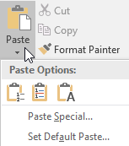
- Hover over the different paste options to see how text would appear each that paste option. When you have determined the best option, click on that option to paste.

Editing a Document

Navigating in a Document
Cursor Movement
Function | Keystroke
Right one Word | Ctrl + Right Arrow
Left one Word | Ctrl + Left Arrow
Down one Paragraph | Ctrl + Down Arrow
Up one Paragraph | Ctrl + Up Arrow
Beginning of Document | Ctrl + Home
End of Document | Ctrl + End
Beginning of Line | Home
End of Line | End
Page Down | Ctrl + Page Down
Page Up | Ctrl + Page Up

Selecting Text
Select Text
Function |  | Keystroke
Select text using keystrokes | Use Shift + any above listed Cursor Movement Keys
Select a Word | Double click the word
Select a Sentence | Ctrl + click in the sentence
Select a Paragraph | Triple Click the Paragraph; or  Double Click in the Selection Bar
Select the Entire Document | Ctrl + A; or  Triple Click in the Selection bar
Select a Line | Click in the selection bar
Select a Rectangle | Alt +Drag
Select a block of text | Click at the beginning and  Shift + Click at the end of the text
Select multiple non-contiguous blocks of text. | Select the first block of text  Ctrl + drag across any other blocks of text.

Document Navigation Pane
The Navigation Pane displays a window that opens on the left side of your screen. It has three tabs displaying different navigational views.
The first tab and allows you to go directly to a document heading that has a style applied by clicking on the heading in the pane. Headings are displayed in outline format. This allows you to collapse or expand headings by clicking on arrows to the left of the headings, move sections of your document by dragging the headings to a new location, show only certain levels of headings, promote and demote headings etc. Simply right click in the document map area to display the menu choices below.
- Select View, Navigation Pane.
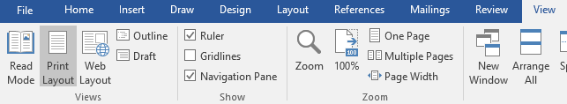
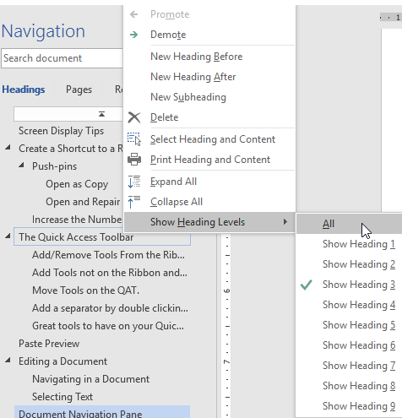
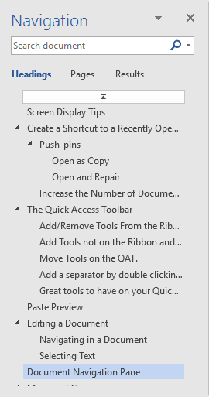
Drag a heading to a new location to move a heading section to a new location in your document.
Click on heading to go to that heading in the document
Click Arrow to expand/collapse a heading family
Right click a heading to view even more options when working with headings.

- Click on any Heading to go to that heading.
- Drag a Heading to move it and its contents to a new location in your document.
- Right click in the Navigation pane to view additional options for working with headings.
- Close the Navigation pane by clicking the X in the top right corner of the Navigation pane or clear the check in the View, Navigation Pane box.

Move and Copy

Using Drag and Drop
- Select the text or object you wish to Move or Copy.
- Move - Use your mouse to point to the selected area (your mouse should change shape to a pointer). Drag the text or object to the desired location; or
- Copy - Use your right mouse to point to the selected area (your mouse should change shape to a pointer). Drag with your right mouse button to the desired location. When you let go of the mouse and the shortcut menu appears: select Copy.

Using the Clipboard Pane
The Clipboard allows you to copy or move up to 24 different selections at a time. Items on the Clipboard stay there until you exit out of the last Office program. Items can be copied or moved to other office programs from the Clipboard as well.
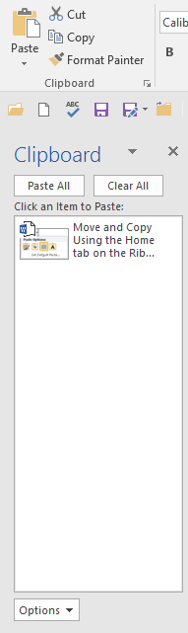

- Display the Office Clipboard and set the option for displaying the Office Clipboard by pressing Ctrl + C twice.
- Select the Clipboard Dialog Launcher on the Home tab.
The Clipboard is displayed on the left side of the screen.
- Select Options at the bottom of the Clipboard and select Show Office Clipboard When Ctrl + C Pressed Twice. Click off the list to make it disappear.
- Use the Clipboard
- Select the text or object you wish to Move or Copy.
- Cut or Copy the text or object using the Home tab or Keystrokes.
- Click where you want the text or object to appear.
- Click the snippet of text you wish to paste in the Clipboard Pane.
- Close the Clipboard by clicking the “X” on the top right corner of the Clipboard.

Formatting Text

Copy Formatting Using the Format Painter
To apply formatting using the format painter, first highlight the paragraph or text from which you wish to copy the formatting (make sure you include the paragraph symbol if you are trying to copy a paragraph formatting). Then double-click the Format Painter tool and drag across text where the style is to be applied. To stop the format painter: click the Format Paint tool again or press ESC on the keyboard.

- Copy the formatting from the first paragraph to the next two paragraphs.
- Triple click the first paragraph to select it.
- Double click the Format Painter.
- Drag the across the next two paragraphs (see example below).
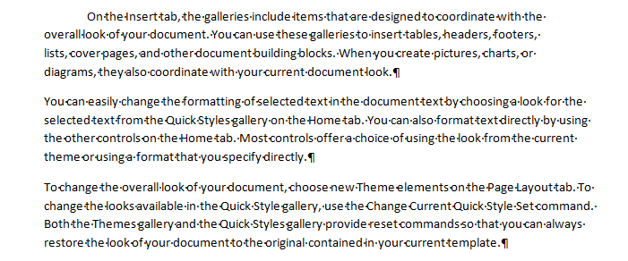

Screen Capture Tool
Screen Capture allows you to capture any area of the screen without using a third party program.

Inserting an Entire Screenshot of any Open Window
If you select Insert, Screenshot, Word displays screenshots of all open windows in the screenshot gallery. Simply click on a screenshot to insert it into your document at the insertion point.

Take a Screen Clip
If you only wish to insert a portion of your screen, first go to the window where the shot is to be taken. Then go back to Word and select Insert, Screenshot, Screen Clipping. The last screen you displayed is redisplayed (but faded) with some crosshairs for you to drag a selection. The area of the screen you select with the crosshairs is ‘cut’ and pasted into your Word document at the insertion point. You can use the Picture Tools tab to help edit your new image.

Building Blocks/Quick Parts
Building Blocks are a greatly expanded version of AutoText. Building blocks store text, graphics and other objects. They are categorized by function and organized in galleries. You can store Building blocks in any gallery, but different galleries will appear in different places. For example, if you store text in the Headers gallery it will appear when creating a header, where a building block stored in the Quick Parts category will appear under Insert, Quick Parts.

Quick Parts Gallery
Quick Parts are reusable potions of formatted text, graphics etc. that can quickly be inserted into your documents. You can use Quick Parts to add the Filename and Path to your document.

Create an AutoText Quick Part

- Create an AutoText Quick Part to Insert a letter closing.
- Type a closing for a letter and then select the text:
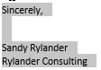
- Select Insert, AutoText, Save Selection to AutoText Gallery.
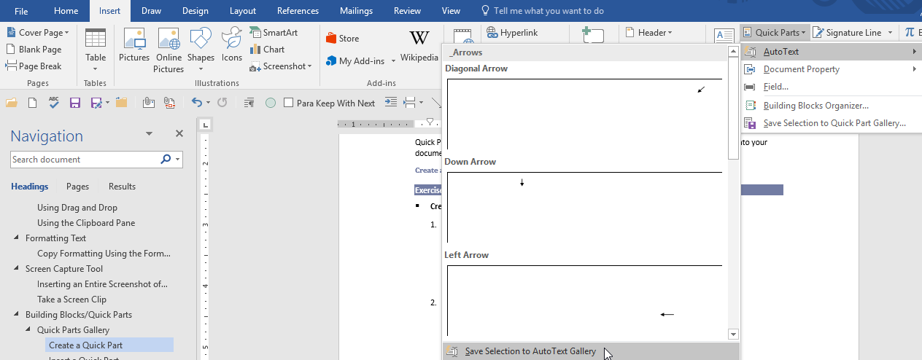
- Change the Building Block Name to ClosingSR and click OK.
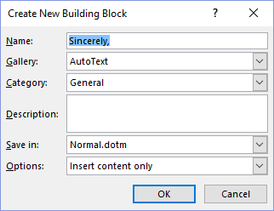
Tip To store paragraph formatting — i.e. indentation, alignment, line spacing, and pagination, include the paragraph mark () in the selection.
Tip If you have a set of related AutoText entries, consider starting all of the names with the same first word to group the pieces together when necessary, such as TrainingTable, TrainingHeader, and TrainingFooter etc.
Tip To have this AutoText entry appear at the top of the list of options, use a symbol like an asterisk at the beginning of the name (i.e. *FileName and Path).

Insert an AutoText Quick Part

- Insert the ClosingSR AutoText
- Select Insert, Quick Parts, AutoText.
- Click the ClosingSR AutoText to Insert at the Current Document Position; or
- Right click the ClosingSR AutoText and select from the menu below to insert in a different location.
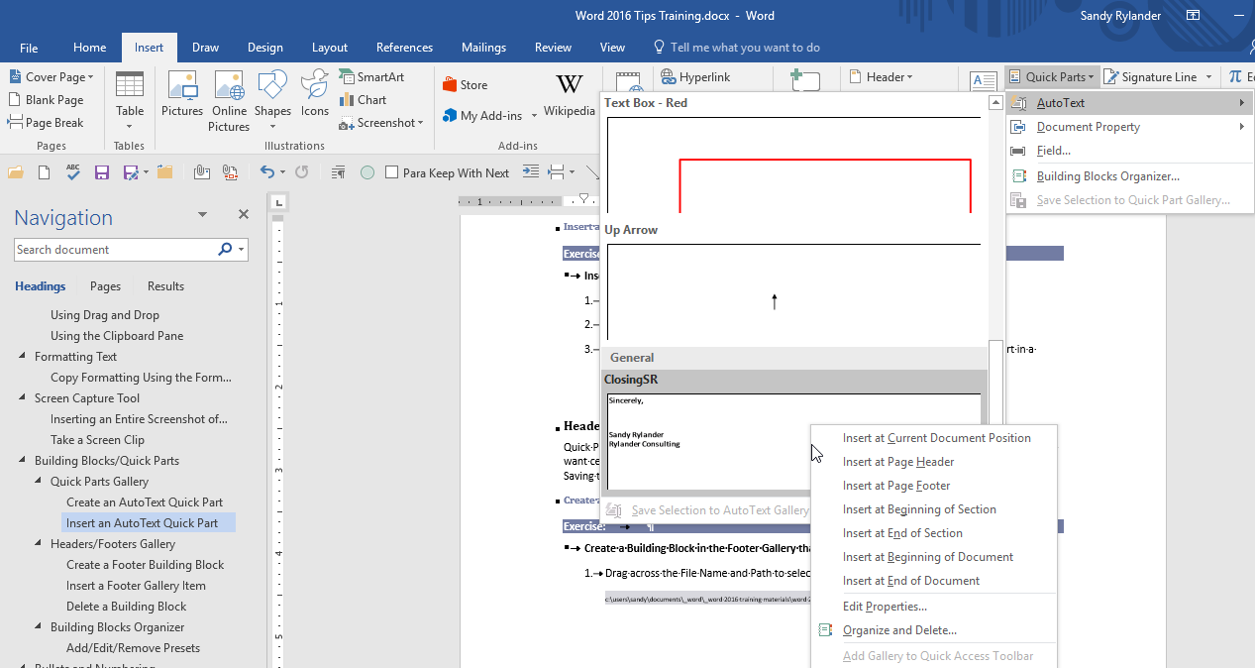

Headers/Footers Gallery
Quick Parts are reusable great for text you want to insert right at the insertion point, but you may always want certain text in a Header or Footer. Many companies like the file name and path in the footer. Saving the same entry to the Footers Gallery will automatically insert the field into the footer.

Delete a Building Block
- Select Insert, Quick Parts, Building Blocks Organizer
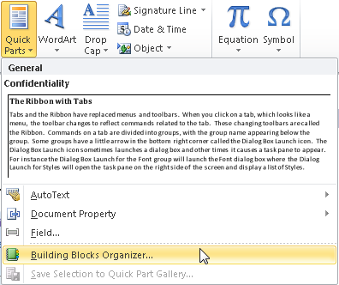
- Select the Building Block you wish to delete and click Delete.
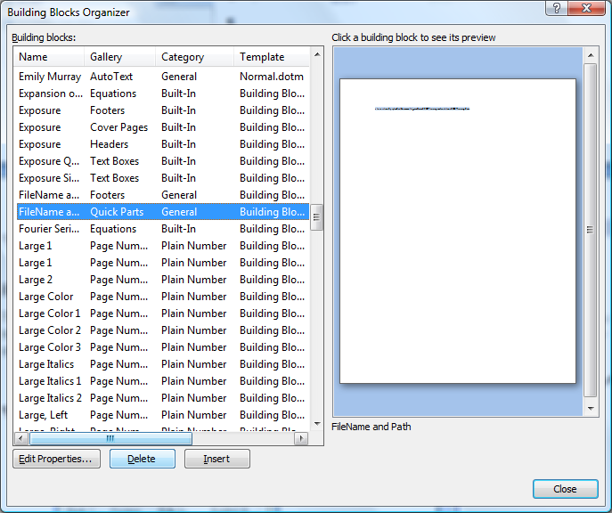

Building Blocks Organizer
The Building Blocks Organizer allows you to View, Insert, Delete or Edit Properties of Building Blocks.
- Display the Building Blocks Organizer by selecting Insert, Quick Parts, Building Blocks Organizer.
- Building Blocks are displayed sorted by Name. To display the list in a different order, click the heading desired at the top of the table (i.e. click Gallery, Category etc.).
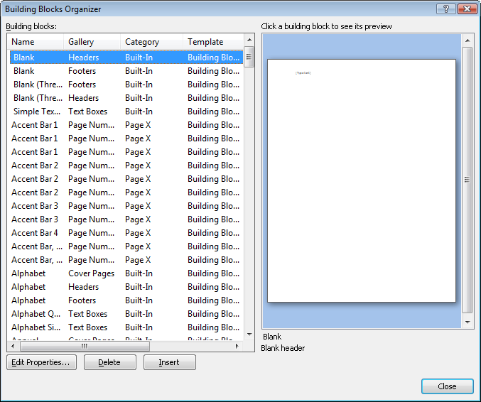
Change sort order by clicking on the column heading.
- Select Edit Properties, if you wish to change any Building Block properties.
- Select a different Gallery (see a list of choices below).
Quick Parts is the default gallery and is great for things you use a lot, but if you add too many to this category it will become unwieldy and difficult to use.
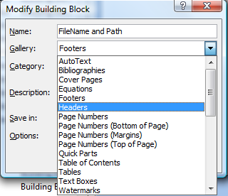
- Select a Category or create a new category. If you create a new category, give it a name and click OK.
Tip To have this Building Block appear at the top of the list of categories, use a symbol like an asterisk at the beginning of the name, i.e. *Document Essentials, or enclose the name in parenthesis, i.e. (Document Essentials).
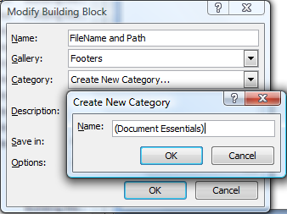
- Save in Building Blocks.dotx. This default makes the Building Block available to all documents.
- Select one of the Options: Insert content only, Insert content in its own paragraph, or Insert content in its own page.
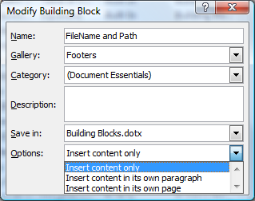
- Add a description if desired.
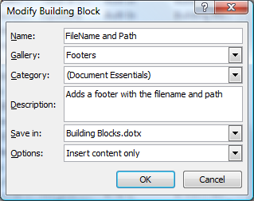
- When you click OK on the Modify Building Block properties and the following box appears, click Yes to save with the new information.
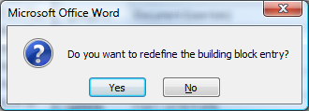
- Notice the new Category. Click Close when done.
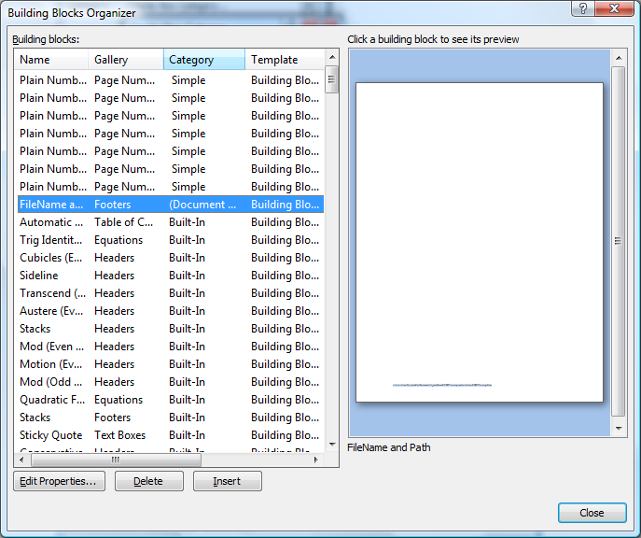
Sorted by Category
Notice the new Category
Tip All Building Blocks can be inserted from the Insert, Quick Parts, Building Blocks Organizer.

Add/Edit/Remove Presets
Some Galleries like the Header and Footer galleries allow you to Edit or Remove entries simply by right clicking on the entry and selecting Edit or Remove. You can also add an entry by selecting the entry text and selecting the Save Selection To Header Gallery… at the bottom of the Insert Header options.
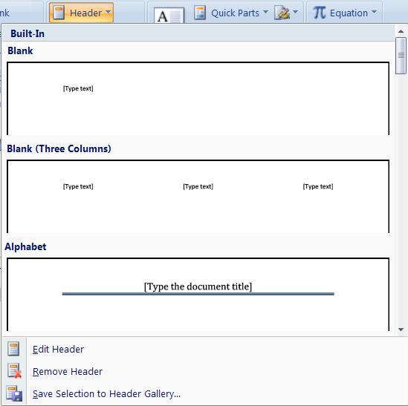

- Add a Header preset.
- Select Insert, Header tool. There are several pre-defined headers that can be selected simply by clicking them. Click Blank (Three Columns) header to insert that header (it is the second option on the Header preset list.
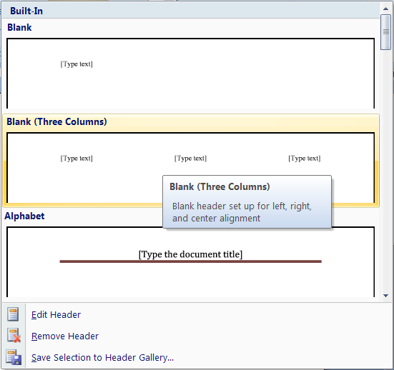
- The new header is inserted with text fields where text is to be inserted.
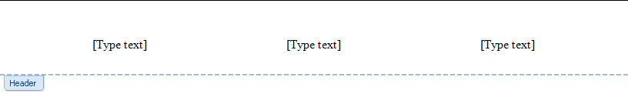
- Click to select the first text field. Click Date & Time on the tab. When the Date & Time dialog box appears, check the Update Automatically box, select the Date format shown below and click OK.
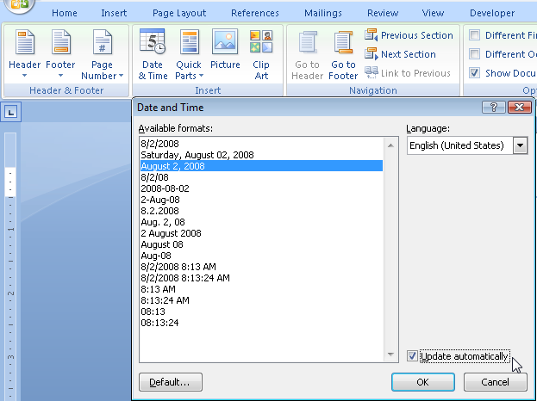
- Complete the header as shown below (substitute your name for the name on the right).
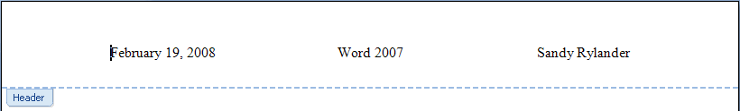
- To make this new header a preset, press Ctrl + A to select the entire header and then select Header, Save Selection to Header Gallery.
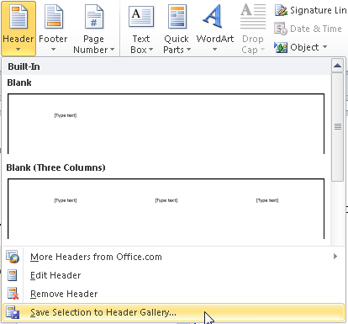
- Fill out the Create New Building Block dialog box as shown below and click OK.
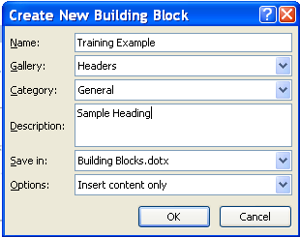
- Start a new document.
- Insert the Header you just created by selecting Insert, Header. Scroll to the bottom of the presets and click the Training Example preset. Notice that it creates the entire header for you.

Find, Advanced Find and Replace
Find now displays the search tab on the Navigation pane to find text. Advanced find or replace will replace text, formatting, non-printing characters (i.e. paragraph breaks, tabs etc.). You can use the Binocular tool on the right side of the Home tab to select Find, Advanced Find or Replace.
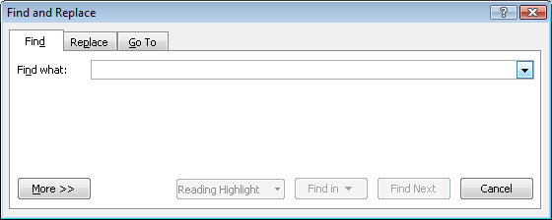
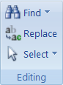

Find – Navigation Pane Search
When you select find on the Home tab, the Navigation Pane search tab is displayed. Type the text you want to find in the text box at the top of the pane. When done with the search, click the “x” on the right side of the search text box. Notice that snippets of the found text appear in the Navigation pane and each occurrence of find is highlighted in yellow in the document.
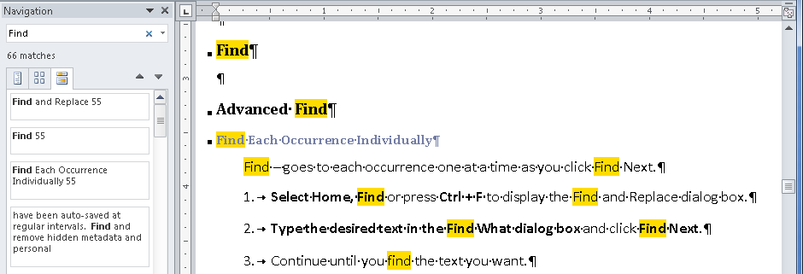

Advanced Find
Advanced Find is on the Find drop-down on the Home tab. Advanced Find displays the Find and Replace dialog box.
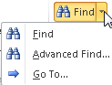

Find Each Occurrence Individually
Find – goes to each occurrence one at a time as you click Find Next.
- Select Home, Find or press Ctrl + F to display the Find and Replace dialog box.
- Type the desired text in the Find What dialog box and click Find Next.
- Continue until you find the text you want.

Select All Instances of Found Text
Select All – selects all occurrences in the desired location at once. You then scroll through your document to view all the selected text.
- Click Find in and select Main Document or any of the other options desired.
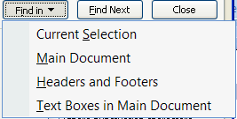

Highlight All Instances of Found Text
Highlight All – highlights all occurrences in the desired location at once. You then scroll through your document to view all the highlighted text.
- Click Reading Highlight and select Highlight All.
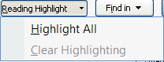
- After you have finished examining all the instances found, remove highlighting by selecting Reading Highlight and Clear Highlighting.

- Click More to see more options:

More Options
Match Case | Only finds text typed in the same case as what is typed in the Find What box (i.e. Word will not find word).
Find Whole Words Only | Find only the word (i.e. the will not find other).
Use Wildcards | You can use wildcards in the search to find any character:  ^? – any character  ^# – any digit  ^$ – any letter
Sounds Like | Finds words that are pronounced the same way (i.e. Cathy and Kathy)
Find All Word Forms | Finds words that are not spelled the same (i.e. is will find are, am, was, were and be)
Match Prefix | Finds string only at the beginning of a word.
Match Suffix | Finds string only at the end of a word.
Ignore Punctuation Characters | Ignores punctuation (i.e. Home Find would also find Home, Find) – be sure to search for the words without punctuation (i.e. Home Find)!!
Ignore White-Space Characters | Ignores white space in the search (i.e. AnnieLee and would also find Annie Lee) – be sure to search for the words without white space (i.e. AnnieLee)!
Format | Font, Paragraph, Tabs, Language, Frame, Style and Highlight
Special | Special Characters – (i.e. Paragraph Marks, Tab Character etc.)

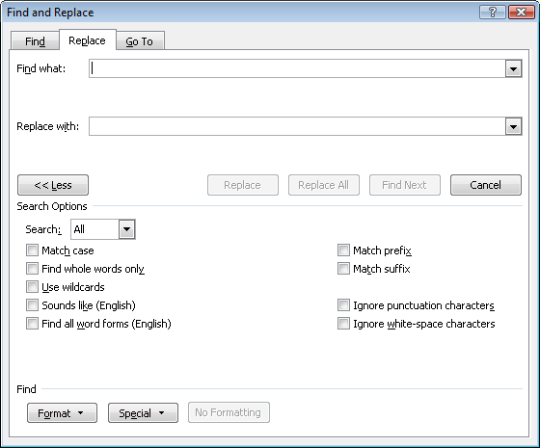

Replace
Replace can find and replace text, formatting, codes etc. Be very careful when using Replace All, however. You can get unexpected results (i.e. if you replace “the” with “an” you may find other replaced with oanr)!
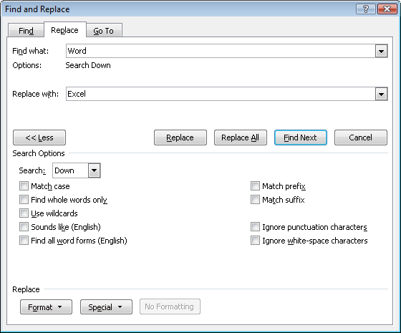
- Select Home, Replace or press Ctrl + H to display the Find and Replace dialog box.
- Type the desired text in the Find What and the Replace With boxes and click Find Next to find the first occurrence of the text.
- Either click Replace to replace the text or Find Next to skip that instance.
- Continue until you find and replace the desired text.
- More – Definitions of options available when selecting the More button are on page 27.
Some Favorite Caret Codes for Special Characters
Symbol | Code | Where Available
Paragraph Mark | ^p | Find What/Replace With
Tab Character | ^t | Find What/Replace With
White space | ^w | Find What
Manual line break | ^l | Find What/Replace With
Manual page break | ^m | Find What/Replace With
Section break | ^b | Find What
Section Symbol (§) | ^% | Find What/Replace With
Paragraph Symbol (¶) | ^v | Find What/Replace With
Clipboard Contents ** | ^c | Replace With
Graphic | ^g | Find What
** Not on menu, but very helpful!

Appendix A –Word Shortcuts
Function | Keystroke | Function | Keystroke
Formatting Text - Character |  | Cursor Movement
Bold | Ctrl + B | Beginning of Document | Ctrl + Home
Italics | Ctrl + I | End of Document | Ctrl + End
Underline | Ctrl + U | Beginning of Line | Home
Change Case | Shift + F3 | End of Line | End
 |  | Down one Paragraph | Ctrl + Down Arrow
 |  | Up one Paragraph | Ctrl + Up Arrow
Remove Character Formatting | Ctrl + Spacebar | Page Up/Page Down | Ctrl + Page Up / Ctrl + Page Down
Formatting Text - Paragraph |  | Select Text
Single Space | Ctrl + 1 | Using keystrokes | Use Shift + any Cursor Movement Key
Double Space | Ctrl + 2 | Contiguous Text | Click at the beginning of the text.  Shift + Click at the end of the text.
Blank Line Before a Paragraph | Ctrl + 0 | Non-contiguous Text | Drag across the first section of text.  Hold the Ctrl key down and drag across each of the subsequent sections of text.
Left Justify | Ctrl + L | Select a Word | Double-Click the word
Center Justify | Ctrl + E | Select a Sentence | Ctrl + Click the sentence
Right Justify | Ctrl + R | Select a Paragraph | Triple Click the Paragraph or Double Click in the Selection Bar
Full Justify | Ctrl + J | Select the Entire Document | Ctrl + A, or Triple Click in the Selection bar
Increase Indent | Ctrl + M | Select a Line | Click in the selection bar
Reduce Indent | Ctrl + Shift + M | Select a Rectangle | Alt + Drag
Remove Paragraph Formatting | Ctrl + Q
Insert Special Characters |  | Document Commands
Non-Breaking Space | Ctrl + Shift + Spacebar | Print a Document | Ctrl + P
Non-Breaking Hyphen | Ctrl + Shift + Hyphen | Switch to next screen | Ctrl + F6 of Alt + F6
Line Break | Shift + Enter | Switch to previous screen | Ctrl + Shift + F6 or Alt + Shift + F6
Page Break | Ctrl + Enter | Close a Document | Ctrl + F4
 |  | Save a Document | Ctrl + S
Fields |  | Move/Copy/Undo
Update | F9 | Cut | Ctrl + X
Insert | Ctrl + F9 | Copy | Ctrl + C
Toggle Field Code/Result | Shift + F9 | Paste | Ctrl + V
Toggle field codes and results | Alt + F9 | Copy Formatting | Ctrl + Shift + C
Unlink Fields | Ctrl + Shift + F9 | Paste Formatting | Ctrl + Shift + V
Next Field | F11 | Clipboard (up to 24 items) | Ctrl + C twice to display
Previous Field | Shift + F11 | Undo | Ctrl + Z
Other Commands |  | Other Commands
Find or Replace | Ctrl + F | Repeat | F4 or Ctrl + Y
Go To | Ctrl + G
Tables- Adjust Size of Columns/Table
Resize all columns to the right in proportion to their original width | Drag the border without holding down any keys | Adjust all columns to the right equally; does not change column width | Ctrl + Drag
Change only the width of the column to the left; does not change table width | Shift + Drag border | Leave columns to the right unchanged; adjust the table proportionally. | Ctrl + Shift + Drag
Best Fit | Double Click border | Resize Entire Table | Drag resize handle in bottom - right corner of table.
Tables- Navigation |  | Table - Select
Top of Current Column Bottom of Current Column | Alt + PageUp  Alt + PageDown | Table | Click the icon in the top left corner of the table
Beginning of Row  End of Row | Alt + Home  Alt + End
Add a Blank Line Above a Table | Place insertion point in front of text in first cell of table and press: Enter

